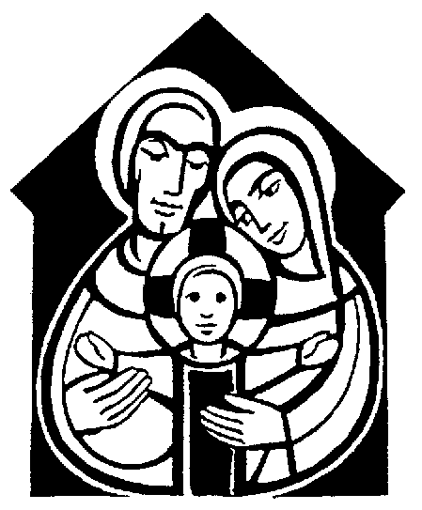

**ST ANDREW, ORFORD WITH LONGFORD**

**Crib Service 2018**

Christmas Eve

**First carol**: Once in Royal David's city

stood a lowly cattle shed,

where a mother laid her baby

in a manger for his bed:

Mary was that mother mild,

Jesus Christ her little child.

He came down to earth from heaven

who is God and Lord of all,

and his shelter was a stable,

and his cradle was a stall;

With the poor and mean and lowly

lived on earth our Saviour holy.

And our eyes at last shall see him

through his own redeeming love,

for that child so dear and gentle

is our Lord in heaven above;

and he leads his children on

to the place where he is gone.

Not in that poor lowly stable,

with the oxen standing by,

we shall see him; but in heaven,

set at God's right hand on high;

where like stars his children crowned

all in white shall wait around.

Opening words and welcome

**“Mary’s surprise”**

## An angel is placed in the Stable

**Carol:** Little Donkey, little donkey, on the dusty road;

Got to keep on plodding onwards, with your precious load.

Been a long time, little donkey, thro’ the winter’s night.

Don’t give up now, little donkey, Bethlehem’s in sight.

Ring out the bells tonight, Bethlehem, Bethlehem;

Follow that star tonight ,Bethlehem, Bethlehem,

Little donkey, little donkey, had a heavy day,

Little donkey, carry Mary, safely on her way

Little donkey, little donkey, journey’s end is near.

There are wise men waiting for a sign to bring them here.

Do not falter, little donkey, there’s a star ahead.

It will guide you, little donkey, to a cattle shed.

Ring out the bells tonight, Bethlehem, Bethlehem;

Follow that star tonight, Bethlehem, Bethlehem,

Little donkey, little donkey, had a heavy day,

Little donkey, carry Mary, safely on her way

Little donkey, carry Mary, safely on her way.

Little donkey, carry Mary, safely on her way

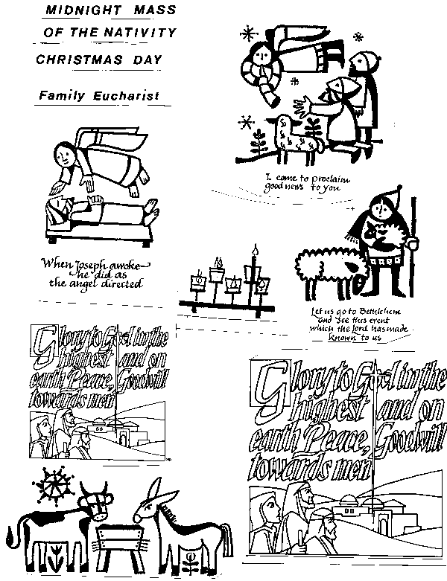**“Bad news, good news”**

## An ox is placed in the Stable

**Carol:** Silent night, holy night,

All is calm, all is bright;

Round yon virgin Mother and Child

Holy infant, so tender and mild,

Sleep in heavenly peace,

Sleep in heavenly peace.

Silent night, holy night.

Shepherds quake at the sight,

glories stream from heaven afar,

heavenly hosts sing alleluia;

Christ the Saviour is born,

Christ the Saviour is born.

Silent night, holy night,

Son of God, love's pure light;

Radiance beams from thy holy face,

With the dawn of redeeming grace,

Jesus Lord at thy birth,

Jesus Lord at thy birth.

**“Journey to Bethlehem”**

## Mary, Joseph and the Donkey are placed in the Stable,

## followed by the baby Jesus

**Carol:** While shepherds watched their flocks by night,

all seated on the ground,

the angel of the Lord came down,

and glory shone around.

‘Fear not’ said he (for mighty dread

had seized their troubled mind);

‘glad tidings of great joy I bring

to you and all mankind.

‘To you in David’s town this day

is born of David’s line

a Saviour, who is Christ the Lord;

and this shall be the sign:

‘the heavenly babe you there shall find

to human view displayed,

all meanly wrapped in swathing bands,

and in a manger laid.’

Thus spake the seraph, and forthwith

appeared a shining throng

of angels praising God, who thus

addressed their joyful song:

‘All glory be to God on high,

and to the earth be peace:

good will henceforth from heaven to men

begin and never cease.’

**“The Smallest Shepherd”**

## The shepherds are placed in the Stable

**Carol:** We three kings of orient are;

Bearing gifts we traverse afar

Field and fountain, moor and mountain,

Following yonder star:

*O star of wonder, star of night,*

*Star with royal beauty bright,*

*Westward leading, still proceeding,*

*Guide us to thy perfect light.*

Born a king on Bethlehem plain,

Gold I bring to crown him again

King for ever, ceasing never,

Over us all to reign:

*O star of wonder ...*

Frankincense to offer have I;

Incense owns a deity nigh:

Prayer and praising, all men raising,

Worship him, God most high:

*O star of wonder, star of night,*

*Star with royal beauty bright,*

*Westward leading, still proceeding,*

*Guide us to thy perfect light.*

Myrrh is mine; its bitter perfume

Breathes a life of gathering gloom;

Sorrowing, sighing, bleeding, dying,

Sealed in the stone-cold tomb:

*O star of wonder ...*

Glorious now, behold him arise,

King, and God, and sacrifice!

Heav'n sings alleluia

Alleluia the earth replies:

*O star of wonder ...*

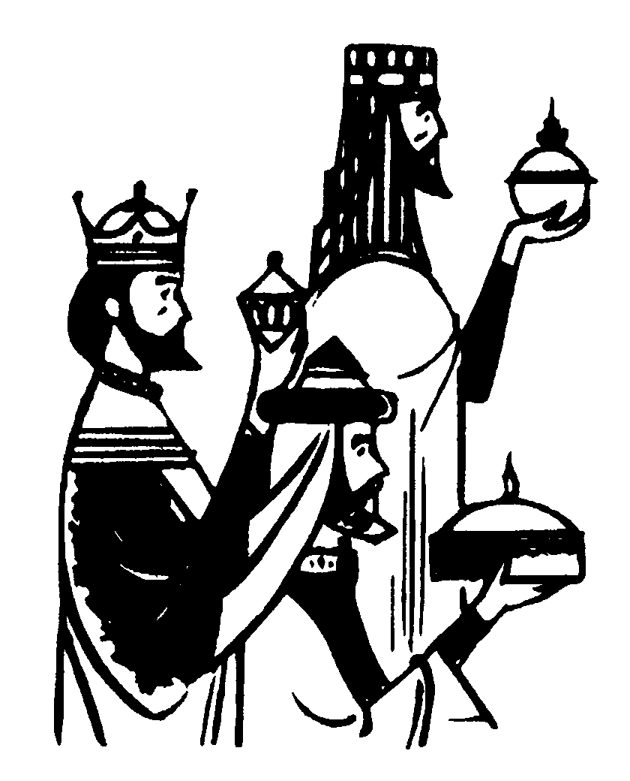 **“Heavenly Hallelujah”**

## The Wise Men are placed in the Stable

**Carol:** See him lying on a bed of straw:

A draughty stable with an open door;

Mary cradling the babe she bore –

The Prince of Glory is his name.

*O now carry me to Bethlehem*

*To see the Lord appear to men!*

*Just as poor as was the stable then,*

*The Prince of Glory when he came.*

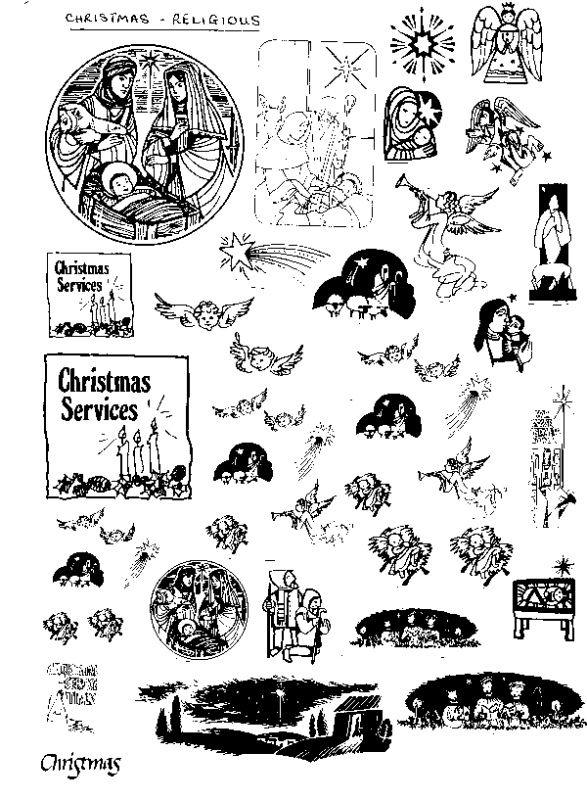Star of silver, sweep across the skies,

Show where Jesus in the manger lies;

Shepherds swiftly from your stupor rise

To see the Saviour of the world!

*O now carry me to Bethlehem …*

Angels, sing the song that you began,

Bring God’s glory to the heart of man;

Sing that Beth’lem’s little baby can

Be salvation to the soul.

O now carry me to Bethlehem …

**“Jasper’s new friend ... and ours”**

## Church Mice and others are placed in the Stable

**Carol:** Away in a manger, no crib for a bed,

The little Lord Jesus laid down his sweet head,

The stars in the bright sky looked down where he lay,

The little Lord Jesus asleep on the hay.

The cattle are lowing, the baby awakes,

But little Lord Jesus no crying he makes;

I love thee Lord Jesus look down from the sky,

And stay by my side until morning is nigh.

Be near me Lord Jesus, I ask Thee to stay,

Close by me for ever and love me I pray,

Bless all the dear children in thy tender care,

And fit us for heaven to live with thee there.

**The Prayers, Lord’s Prayer and Blessing**

**Carol:** *Come and join the celebration’ it’s a very special day;*

*come and share our jubilation, there’s a new King born today!*

See the shepherds hurry down to Bethlehem;

gaze in wonder at the Son of God who lay before them.

‘God is with us’, round the world the message sing;

he is with us, ‘Welcome!’ all the bells on earth are pealing.

**\*\* Christmas Services \*\***

Tonight: 11.30pm Midnight Mass

Christmas Day: 10.00am Sung Family Communion with Carols

Our regular Sunday Service starts at 10 o’clock, lasts about an hour. Everyone is welcome to the service.

Christmas 2016: Theme of journeys – not just Mary, but shepherds, wise men etc and also our journey to the crib to worship him. Readings from “Christmas Stories for Little Angels” by Sarah J Dodd

32-ish present plus 20 children.

Try to adjust carols to follow the reading, rather than pre-empt them.

**First reading:** *Luke 2. 1-5*

In those days, an order went out from Caesar Augustus that all the world should be registered. This was the first enrolment, and all went, each to his own city. Joseph also went up from Galilee, from the city of Nazareth, to Judea, to the city of David which is called Bethlehem, to be enrolled with Mary, his betrothed, who was with child.

**Second Reading**: *Luke 2. 6-7*

And while they were in Bethlehem, the time came for Mary to be delivered. And she gave birth to her first-born son and wrapped him in swaddling cloths, and laid him in a manger, because there was no place for them in the inn.

**Third reading:** Luke 2. 8-12

And in that region there were shepherds out in the field, keeping watch over their flocks by night. And an angel of the Lord appeared to them, and the glory of the Lord shone around them, and they were filled with fear. And the angel said to them, ‘Do not be afraid; for behold, I bring you good news of a great joy which will come to all the people; for to you is born this day in the city of David a Saviour, who is Christ the Lord. And this will be a sign for you: you shall find a babe wrapped in swaddling cloths and lying in a manger.’ And suddenly there was with the angel a multitude of the heavenly host praising God and saying: ‘Glory to God in the highest, and on earth, peace among men with whom he is pleased.’

**Final reading**: Matthew 2. 1-2, 9-11

Now when Jesus was born in Bethlehem in the days of Herod the King, wise men from the East came to Jerusalem, saying’ “Where is he that is born King of the Jews? For we have seen his star in the East and have come to worship him.” After they had heard King Herod, the star which they had seen in the East went before them, till it came to rest over the place where the child was. When they saw the star, they rejoiced exceedingly with great joy; and going into the house they saw the child, with Mary his mother, and they fell down and worshipped him. Then, opening their treasures, they offered him gifts, gold and frankincense and myrrh.